Protocol for sharing genetic samples of Striped Marlin collected by Japan, Taiwan, and the United States to elucidate stock structure and dynamics in the North Pacific Ocean

Johanna Bober¹, Masashi Sekino², Yoji Nakamura², Motoshige Yasuike²,
Yuki Ishihara¹, and Mikihiko Kai¹

¹Fisheries Resources Institute, Highly Migratory Resources Division,
²Fisheries Resources Institute, Bioinformatics and Biosciences Division,
Japan Fishery Research and Education Agency
2-12-4 Fukuura, Kanazawa, Yokohama, Kanagawa 236-8648, JAPAN

Email: johanna_bober39@fra.go.jp

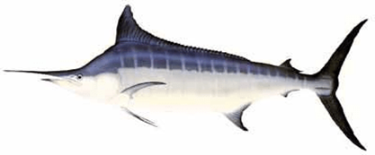

Abstract
The accuracy of stock assessments for Striped Marlin (Kajikia audax) in the Pacific Ocean continues to be affected by uncertainties related to stock structure, seasonal population dynamics and mixing scenarios across stock management area boundaries. In particular, unresolved stock structure in the North Pacific Ocean has led to discrepancies between the groups identified through genetic studies and the stocks recognized by Regional Fisheries Management Organizations. These discrepancies compromise the effectiveness of management measures and ultimately impact the overall stability of fishery resources. Here, we discuss an approach to evaluate the genetic stock structure in relation to temporal dynamics such as putative seasonal migrations to feeding and spawning grounds and life history characteristics across the entire North Pacific Ocean, over a continuous multi-year time frame. This approach aims to address key fundamental uncertainties and improve stock assessments. Furthermore, we present a protocol for sharing genetic samples of Striped Marlin collected by Japan, Taiwan, and the United States to facilitate future studies on stock structure in the North Pacific Ocean.

- Introduction
According to the latest report by the International Scientific Committee for tuna and tuna-like species in the North Pacific Ocean (ISC), specifically the Billfish Working Group (BILLWG), substantial uncertainties in the stock structure of Striped Marlin (MLS, Kajikia audax) in the Western and Central North Pacific Ocean (WCNPO) continue to impede accurate stock assessments (ISC 2023). Currently, three separate stocks are recognized by Regional Fisheries Management Organizations (RFMOs) in the Pacific Ocean:
1. The Eastern Pacific Ocean (EPO) stock, which includes the waters off Ecuador, Peru, and Mexico, and is managed by the Inter-American Tropical Tuna Commission (IATTC).
2. The South-West Pacific Ocean (SWPO) stock, which includes the waters off Australia and New Zealand.
3. The Western and Central North Pacific Ocean (WCNPO) stock, which includes the waters off Japan, Taiwan, and the United States (Hawaii and California).
Both the SWPO and WCNPO stocks are managed by the Western and Central Pacific Fisheries Commission (WCPFC). Although this stock classification reflects spatial structure supported by fisheries data and genetic studies (Graves & McDowell 1994, McDowell & Graves 2008, Purcell & Edmands 2011, Lee et al. 2012), it is also influenced by political considerations. As a result, stock boundaries defined by RFMOs do not necessarily align with the true biological stock structure and its spatio-temporal dynamics. This discrepancy can lead to overfishing or depletion of certain local populations and threaten the overall stability of fishery resources (Cadrin et al. 2014; Kerr et al. 2017).
A yet unresolved population structure of MLS exists particularly in the North Pacific Ocean (NPO). Two recent studies suggest the existence of a fourth genetically distinct group in the Pacific Ocean. Microsatellite marker analysis by Purcell & Edmands (2011) assigned adult fish caught around Hawaii to a different genetic stock than juveniles of the same area, which clustered with individuals from Taiwan, Japan, and the United States (California). An assessment using genome-wide single nucleotide polymorphism (SNP) markers by Mamoozadeh et al. (2020) further confirmed this genetic stock structuring. Based on these findings, there may be two distinct populations in the WCNPO: one stock (mainly juveniles) distributed across the expansive NPO, including the waters off Japan, Taiwan, Hawaii, and California, and a second stock (mainly adults) found in the waters off Japan and Hawaii (Purcell & Edmands 2011; Mamoozadeh et al. 2020). However, Martinez et al. (2025) demonstrated that the previous findings regarding the fourth genetically distinct group were due to sample cross-contamination and supported the hypothesis of a single NPO stock. Consequently, based on the latest information, it has been confirmed that three stocks (i.e., EPO, SWPO, and WCNPO) exist in the Pacific Ocean.
Stock assessments have been also complicated by spatio-temporal patterns associated with life history parameters of fish caught in the CNPO (Humphreys & Brodziak 2024), particularly in relation to body lengths (Sculley 2019; Brodziak & Sculley 2022). Seasonal shifts in eye-fork-length (EFL) distributions have been observed, with larger MLS primarily caught in northern waters off the Hawaiian Islands and during the second (April-June) and third quarter (July-September) of the year, while smaller fish dominated catches in southern and western waters and during the first (January-March) and fourth quarter (October-December). Lam et al. (2022) confirmed this size-based partitioning and further assigned individuals to genetic stocks. Larger fish (>160 cm EFL) from the SWPO and NPO stocks were predominantly found mixing north of Hawaii in June, whereas southern Hawaiian waters consisted mainly of smaller fish (<160 cm EFL) from the NPO stock in July.
Evidence of year-round mixing of NPO and SWPO stocks in Hawaiian waters has recently accumulated through assessments of genetic stock structure based on the samples collected by the Australian Eastern Tuna and Billfish Fishery (ETBF) and the Hawaiian Pelagic Longline Fishery (HPLF) (Evans et al. 2021, Martinez et al. 2025). Consequently, it has been strongly emphasized that the CNPO – particularly around Hawaiian waters, previously proposed to function as a spawning ground as well as nursery and feeding habitat for juveniles and young adults from multiple populations (Sculley 2019; Humphreys & Brodziak 2019) – appears to be a dynamic mixing zone of different regional stocks across management boundaries.
To date, our understanding of stock mixing is derived from only a few studies, primarily confined to areas where MLS are caught by HPLF. Although tagging and genetic studies provide evidence of connectivity among MLS in the CNPO, SWPO, and EPO (Mamoozadeh et al. 2020; Evans et al. 2021; Lam et al. 2022), connectivity between the Western North Pacific Ocean (WNPO – the waters off Japan and Taiwan) and adjacent areas remains largely unknown. However, seasonal interactions with multiple stocks may occur (Mamoozadeh et al. 2020).
Assessing genetic stock structure in relation to temporal dynamics (e.g. seasonal migrations to feeding and spawning grounds) and life history traits across the NPO is a crucial approach to resolving key uncertainties and gaining a comprehensive understanding. This genetic approach, combined with tagging studies, will enhance the accuracy of future WCNPO stock assessments conducted by the ISC.

- Objectives
The aim of this study is to focus primarily on the stock structure of MLS in the NPO, north of the equator, and to analyze it by considering spatial-temporal dynamics and life history traits, in order to establish a solid foundation for WCNPO stock assessments. To achieve a comprehensive understanding of the stock structure and potential seasonal shifts in population composition resulting from the species' high migratory behavior, it is necessary to collect a large number of randomly sampled specimens from a broad area encompassing the western, central, and eastern NPO across multiple seasons and years.
The total number of currently available MLS tissue samples was summarized based on the latest International Billfish Biological Sampling (IBBS) project database and tissue samples provided by WCPFC (Table 1). However, for the WCPFC tissue samples – assessed through the Pacific Marine Specimen Bank (PMSB) search tool – detailed coordinates data are not available, rendering them unsuitable for the intended analysis.
If genetic analyses combine muscle tissue samples from Japan, Taiwan, and the United States – available through the IBBS database – the area coverage and data volume will increase substantially (Figure 1). The IBBS project was initiated by the ISC BILLWG in 2020 to improve the stock assessment of MLS, Swordfish (Xiphias gladius) and Blue Marlin (Makaira mazara) by providing accurate estimates of life history parameters such as maturity and growth across the NPO (Kinney et al. 2020). The inclusion of genetic data from the IBBS project further ensures that reliable information on key life history traits is available for these samples, enabling robust analysis of genetic stock structure and population dynamics.
As Kinney et al. (2020) noted in their approach to establishing a consistent strategy for collecting billfish samples for life history research, examining samples over a five-year period is appropriate, as it aligns with the recommended stock assessment timeline for billfish in the NPO (ISC 2019). In previous studies on the genetic stock structure of MLS, sample sizes were generally small (Mamoozadeh et al. 2020), particularly in the WNPO, and often lacked representation across consecutive years (Lam et al. 2022). This limitation can introduce bias and hinder a comprehensive understanding of temporal population dynamics.
According to Waples (1998), approximately 50 samples per location are needed to reduce random sampling errors and to detect statistically significant differences among stocks in genetic data analyses. However, obtaining such a large number of samples may be difficult, and even if achieved, it may not be feasible to incorporate all of them into subsequent genotyping-by-sequencing (GBS) analysis due to the high cost of sequencing and the challenges associated with managing large datasets.
Given the importance of investigating stock structure in relation to seasonal dynamics, the target is to include approximately 30 samples per quarter (1: January-March, 2: April-June, 3: July-September and 4: October-December) for each region in the analysis (Table 2). Whenever possible, at least 10 samples per month and region should be included to ensure adequate representation. The regions can be broadly categorized into three areas – Western, Central, and Eastern North Pacific – divided by 160° east and west longitude, consistent with the sampling strategy for life history research described by Kinney et al. (2020).
Based on currently available muscle tissue samples, the CNPO is generally well represented year-round by samples from the United States. In contrast, sample numbers are relatively low in the WCNPO, particularly during the third quarter, and in the easternmost region. Increased sampling in specific areas and seasons may be necessary to meet target sample numbers (Figure 2).

3. Material and Methods
3.1 Collection, handling, and storage of samples
Sampling, preservation, and storage of muscle tissue are currently not standardized (Table 1) and therefore should be unified to provide a consistent basis for future genetic stock structure analyses. The collection, handling, and storage of genetic samples are generally based on the approach described by Kinney et al. (2020), with adjustments made regarding the preservation of samples.
TNES-Urea buffer, as used for Japanese samples, is a convenient method for preserving muscle or liver tissue without the need for freezing, and also serves as a preliminary preparation step for efficient DNA extraction (Asahida et al. 1996). Urea treatment has also been shown to be effective in breaking down hard tissues such as fins or scales due to its protein-denaturing properties, offering a useful alternative to conventional techniques for improving DNA isolation from delicate samples (Wasko et al. 2003).
Muscle tissue samples of MLS already available from the US – stored at -80°C – may be used for genetic analyses. Taiwanese samples stored at -20°C can also be used, provided they have not been stored for more than two years, as prolonged storage may compromise DNA quality.
Recommended procedure for genetic sampling:
- Wipe the body section with a single-use dry cloth. Use a clean knife to cut out a piece of muscle tissue. From the interior of this piece, take a subsample of approximately 1x1 cm (~0.1-0.2 grams) using a single-use biopsy punch, single-use scalpel blade or a clean knife/scalpel. (This step is crucial to prevent cross-contamination by ensuring that the collected tissue has not been in contact with another fish, vessel surfaces, or fishing gear).
- Place the subsample into a labeled, sterile cryogenic vial (~2 ml) filled with TNES-Urea buffer (6M). Secure the label with clear tape to prevent damage.
- If a knife or scalpel is used instead of a single-use biopsy punch or scalpel blade, clean the tool thoroughly – ideally with at least a 3% bleach solution – before sampling tissue from another fish (see Anderson et al. 2023).
- Samples stored in TNES-Urea buffer (6M) can be kept at room temperature until shipment.
- Before shipping, seal the sample vials with parafilm and pack securely.

3.2 Analysis of stock structure
A detailed genetic analysis of MLS at the whole-genome level is necessary to clarify stock structure and enable estimates of spatial-temporal patterns. Single nucleotide polymorphisms (SNPs) are considered ideal genomic markers for characterizing functional genes associated with traits, as they are distributed at high density throughout the genome and, when located in coding regions, can influence protein function and gene expression (Seeb et al. 2011). Whole genome SNP screening facilitates the detection of local adaptive variation (Luikart et al. 2003; Allendorf et al. 2010), thereby supporting the identification of genetic differentiation among populations connected by gene flow.
Genotyping-by-sequencing (GBS) based on restriction site-associated DNA sequencing (RAD-Seq) (Baird et al. 2008) is one of several methods used to identify SNPs in multiple individuals simultaneously through massively parallel high-throughput sequencing (Davey & Blaxter 2011). RAD-seq is widely applied in ecological, evolutionary, and conservation genomics, as it enables genotyping of large sample sets without requiring prior genomic information (Andrews et al. 2016). It has proven effective in detecting genetically distinct populations in highly migratory pelagic fish species such as Yellowfin Tuna (Thunnus albacares) (Grewe et al. 2015; Pecoraro et al. 2016).
RAD-seq is a reduced-representation method that targets and sequences small genomic regions near restriction enzyme recognition sites. However, which on the downside requires substantial quantities of high-quality genomic DNA (> 1 µg) to ensure optimal restriction enzyme digestion (Etter et al. 2011; Hohenlohe et al. 2011). An alternative GBS method is genotyping by random amplicon sequencing (GRAS-Di) (Enoki & Takeuchi 2018), which creates reduced-representation libraries through high-throughput sequencing of PCR-amplified fragments using specialized multiplex PCR primers (Suyama & Matsuki 2015; Hosoya et al. 2019; Miki et al. 2020). Compared to RAD-seq, GRAS-Di offers simpler library preparation and the ability to detect a larger number of SNPs across all chromosomes. It is also less sensitive to poor DNA quality, making it suitable for ecological and conservation studies such as population structure analyses of marine fish, where high-quality DNA may not always be available (Hosoya et al. 2019).
The analysis of population structure among MLS sampled in three regions across the NPO, with respect to season over five consecutive years, is planned using GRAS-Di method and Next Generation Sequencing (NGS) technology to characterize genome-wide SNPs. Only individuals for which sufficient life history data (sex, size, maturity and preferably growth) are available will be included in the genetic analysis. When selecting sample, size, sex, season, and sampling location will be considered to ensure balanced representation of males and females, various size classes, and broad geographic coverage. Samples will be mapped in advance to verify these criteria.
Sequenced data will be analyzed through computational processing, beginning with mapping short-read data to the draft genome of MLS, followed by SNP calling, genotyping via genome-wide association studies (GWAS), and final evaluation of population structure using statistical methods such as cluster analysis and principal component analyses. The overall process from sample collection to data analysis is summarized in Figure 3.
Finally, as a request from Japan to the researchers in the United States and Taiwan, we request the provision of muscle samples from individuals previously collected in the waters around Hawaii and aged using otolith-based daily increment analysis (Furuyama et al. 2024). The handling of these muscle-samples must strictly adhere to the Recommended Procedure for Genetic Sampling outlined above.

References
Allendorf, F. W., Hohenlohe, P. A., & Luikart, G. (2010). Genomics and the future of conservation genetics. Nature reviews genetics, 11(10), 697-709.
Anderson, G., Macdonald, J. I., Potts, J., Feutry, P., Grewe, P. M., Boutigny, M., ... & Nicol, S. J. (2023). Evaluating DNA cross-contamination risk using different tissue sampling procedures on board fishing and research vessels. ICES Journal of Marine Science, 80(4), 728-738.
Andrews, K. R., Good, J. M., Miller, M. R., Luikart, G., & Hohenlohe, P. A. (2016). Harnessing the power of RADseq for ecological and evolutionary genomics. Nature Reviews Genetics, 17(2), 81-92.
Asahida, T., Kobayashi, T., Saitoh, K., & Nakayama, I. (1996). Tissue preservation and total DNA extraction from fish stored at ambient temperature using buffers containing high concentration of urea. Fisheries science, 62(5), 727-730.
Baird, N. A., Etter, P. D., Atwood, T. S., Currey, M. C., Shiver, A. L., Lewis, Z. A., ... & Johnson, E. A. (2008). Rapid SNP discovery and genetic mapping using sequenced RAD markers. PloS one, 3(10), e3376.
Brodziak, J., & Sculley, M. (2022). Observed length composition data for striped marlin, Kajikia audax, in the Hawaii longline fishery, 1994-2020. Working document submitted to the Billfish Working Group of the International Scientific Committee for Tuna and Tuna-like Species in the North Pacific Ocean, ISC/22/BILLWG-01/01. (International Scientific Committee Billfish Working Group) Available at https://isc.fra.go.jp/pdf/BILL/ISC22_BILL_1/ISC_22_ BILLWG-01_01.pdf
Cadrin, S. X., Kerr, L. A., & Mariani, S. (2014). Interdisciplinary evaluation of spatial population structure for definition of fishery management units. In Stock identification methods (pp. 535-552). Academic Press.
Davey, J. W., & Blaxter, M. L. (2010). RADSeq: next-generation population genetics. Briefings in functional genomics, 9(5-6), 416-423.
Enoki, H. & Takeuchi, Y. (2018) New genotyping technology, GRAS-Di, using next generation sequencer. Plant and Animal Genome conference XXVI, San Diego, CA. https://pag.confex.com/pag/xxvi/meetingapp.cgi/Paper/29067.
Evans, K., Grewe, P., Foster, S., Gunasekara, R., & Lansdell, M. (2021). Determination of the spatial dynamics and movement rates of the principal target species within the Eastern Tuna and Billfish Fishery and connectivity with the broader western and central Pacific Ocean-beyond tagging. Fishery Research and Development Corporation, Project number 2016/018. CSIRO Oceans and Atmosphere, Hobart, Tas., Australia. https://www.frdc.com.au/sites/default/files/products/2016-018-DLD.pdf
Etter, P. D., Bassham, S., Hohenlohe, P. A., Johnson, E. A., & Cresko, W. A. (2011). SNP discovery and genotyping for evolutionary genetics using RAD sequencing. In Molecular methods for evolutionary genetics, 157-178).
Furuyama, A., Funabara, M., Arai, Y., Ishihara, Y., Kai, M. & Kanaiwa, M. (2024). The progress of age estimation for striped marlin in the North Pacific. In Report of the ISC Billfish Working Group Workshop, Annex 9 (SC20-SA-WP-13): pp. 3.
Graves, J. E., & McDowell, J. R. (1994). Genetic Analysis of Striped Marlin (Tetrapturus audax) Population Structure in the Pacific Ocean. Canadian Journal of Fisheries and Aquatic Sciences. 51(8): 1762-1768. https://doi.org/10.1139/f94-177
Grewe, P. M., Feutry, P., Hill, P. L., Gunasekera, R. M., Schaefer, K. M., Itano, D. G., ... & Davies, C. R. (2015). Evidence of discrete yellowfin tuna (Thunnus albacares) populations demands rethink of management for this globally important resource. Scientific reports, 5(1), 16916.
Hohenlohe, P. A., Amish, S. J., Catchen, J. M., Allendorf, F. W., & Luikart, G. (2011). Next‐generation RAD sequencing identifies thousands of SNPs for assessing hybridization between rainbow and westslope cutthroat trout. Molecular ecology resources, 11, 117-122.
Hosoya, S., Hirase, S., Kikuchi, K., Nanjo, K., Nakamura, Y., Kohno, H., & Sano, M. (2019). Random PCR‐based genotyping by sequencing technology GRAS‐Di (genotyping by random amplicon sequencing, direct) reveals genetic structure of mangrove fishes. Molecular ecology resources, 19(5), 1153-1163.
Humphreys, R. L., & Brodziak, J. K. (2019). Reproductive maturity of striped marlin (Kajikia audax), in the central North Pacific off Hawaii. In Proceedings of the Billfish Working Group Workshop, Honolulu, HI, USA (pp. 8-15).
Humphreys, R. L., & Brodziak, J. K. (2024). Reproductive dynamics of striped marlin (Kajikia audax) in the central North Pacific. Marine and Freshwater Research, 75(5).
ISC (2023). Stock Assessment Report for Striped Marlin (Kajikia audax) in the Western and Central North Pacific Ocean through 2020. Final document submitted by the Billfish Working Group of the International Scientific Committee for Tuna and Tuna-Like Species in the North Pacific Ocean, ISC/23/ANNEX/14. (ISC Billfish WG) Available at https://isc.fra.go.jp/pdf/ISC23/ISC23_ANNEX14-Stock_Assessment_Report_for_WCNPO_Striped_Marlin-FINAL.pdf
Kerr, L. A., Hintzen, N. T., Cadrin, S. X., Clausen, L. W., Dickey-Collas, M., Goethel, D. R., ... & Nash, R. D. (2017). Lessons learned from practical approaches to reconcile mismatches between biological population structure and stock units of marine fish. ICES Journal of Marine Science, 74(6), 1708-1722.
Kinney, M.J., Chang, Y.J., Ijima, H., Kanaiwa, M., Schemmel, E., & O’Malley, J. (2020). Length-based proportional sampling for life history research: establishing uniform sampling for North Pacific billfish species. ISC/20/BILLWG-02/01.
Lam, C. H., Tam, C., & Lutcavage, M. E. (2022). Connectivity of striped marlin from the Central North Pacific Ocean. Frontiers in Marine Science, 9, 879463.
Lee, H. H., Piner, K., Humphreys, R., & Brodziak, J. (2012). Stock assessment of striped marlin in the western and central North Pacific Ocean in 2011. ISC/Billfish WG, ISC/SAR/MLS/2012, 119 p.
Available at https://isc.fra.go.jp/pdf/Stock_assessment/ISC-BILLWG_2011_Stock_Assessment_of_Striped_Marlin.pdf
Luikart, G., England, P. R., Tallmon, D., Jordan, S., & Taberlet, P. (2003). The power and promise of population genomics: from genotyping to genome typing. Nature reviews genetics, 4(12), 981-994.
Mamoozadeh, N. R., Graves, J. E., & McDowell, J. R. (2020). Genome‐wide SNPs resolve spatiotemporal patterns of connectivity within striped marlin (Kajikia audax), a broadly distributed and highly migratory pelagic species. Evolutionary applications, 13(4), 677-698.
Martinez, J. L., Graves, J. E., & McDowell, J. R. (2025). SNP genotyping reveals a mixed-stock fishery for striped marlin, Kajikia audax, in the central North Pacific Ocean. ICES Journal of Marine Science, 82(9), fsaf156.
McDowell, J. R., & Graves, J. E. (2008). Population structure of striped marlin (Kajikia audax) in the Pacific Ocean based on analysis of microsatellite and mitochondrial DNA. Canadian Journal of Fisheries and Aquatic Sciences, 65(7), 1307-1320.
Miki, Y., Yoshida, K., Enoki, H., Komura, S., Suzuki, K., Inamori, M., ... & Takumi, S. (2020). GRAS-Di system facilitates high-density genetic map construction and QTL identification in recombinant inbred lines of the wheat progenitor Aegilops tauschii. Scientific Reports, 10(1), 21455.
Pecoraro, C., Babbucci, M., Villamor, A., Franch, R., Papetti, C., Leroy, B., ... & Cariani, A. (2016). Methodological assessment of 2b-RAD genotyping technique for population structure inferences in yellowfin tuna (Thunnus albacares). Marine genomics, 25, 43-48.
Purcell, C. M., & Edmands, S. (2011). Resolving the genetic structure of striped marlin, Kajikia audax, in the Pacific Ocean through spatial and temporal sampling of adult and immature fish. Canadian Journal of Fisheries and Aquatic Sciences, 68(11), 1861-1875.
Sculley M. (2019). Striped marlin (Kajikia audax) length data available from 1995-2017 in the Hawaii-based longline fishery. Working document submitted to the Billfish Working Group of the International Scientific Committee for Tuna and Tuna-like Species in the North Pacific Ocean. ISC/19/BILLWG-1/04. p. 16. (ISC Billfish WG) Available at https://isc.fra.go.jp/pdf/BILL/ISC19_BILL_ 1/ISC19_BILLWG_WP1-4.pdf
Seeb, J. E., Carvalho, G., Hauser, L., Naish, K., Roberts, S., & Seeb, L. W. (2011). Single-nucleotide polymorphism (SNP) discovery and applications of SNP genotyping in nonmodel organisms. Molecular ecology resources, 11.
Suyama, Y., & Matsuki, Y. (2015). MIG-seq: an effective PCR-based method for genome-wide single-nucleotide polymorphism genotyping using the next-generation sequencing platform. Scientific reports, 5(1), 16963.
Waples, R. S. (1998). Separating the wheat from the chaff: patterns of genetic differentiation in high gene flow species. Journal of Heredity, 89(5), 438-450.
Wasko, A. P., Martins, C., Oliveira, C., & Foresti, F. (2003). Non‐destructive genetic sampling in fish. An improved method for DNA extraction from fish fins and scales. Hereditas, 138(3), 161-165.

Tables
  - Table 1: Summary of Striped Marlin muscle tissue samples collected by Japan, Taiwan, the United States as of November 26, 2025, and WCPFC (*January 21, 2025).
Nation | Total number of samples | North Pacific samples | South Pacific samples | Time period (Years) | Sample preservation method
Japan | 1298 | 976 | 260 | 1998 - 2025 | - 40 °C and subsample fixed in TNES-Urea
US | 522 | 522 | NA | 2021 - 2025 | - 80 °C
Taiwan | 35 | 35 | NA | 2010, 2020 - 2022 | - 20 °C
WCPFC | 145 | NA | 145 | 2001 – 2024* | - 20 °C

  - Table 2: Example of a study design illustrating ideal minimum number of samples required to evaluate the stock structure of Striped Marlin across the Western (WNPO), Central (CNPO) and Eastern (ENPO) North Pacific Ocean over a five-year time frame, including seasonal sample targets for 1 (Jan-Mar), 2 (Apr-Jun), 3 (Jul-Sep), and 4 (Oct-Dec).
Quarter | WNPO | CNPO | ENPO | Total Samples
1 (Jan-Mar) | 30 | 30 | 30 | 1800
2 (Apr-Jun) | 30 | 30 | 30
3 (Jul-Sep) | 30 | 30 | 30
4 (Oct-Dec) | 30 | 30 | 30

Figures 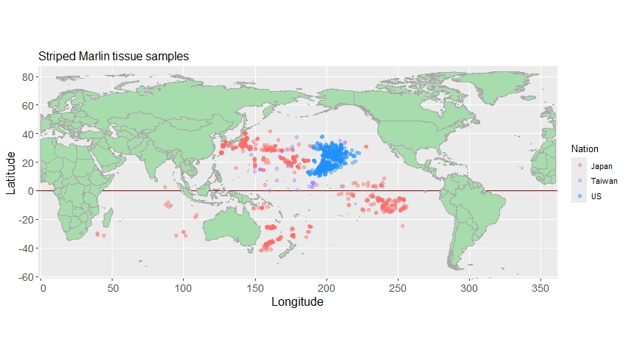
Figure 1 Distribution of Striped Marlin muscle tissue samples collected by Japan, Taiwan, and the United States, based on IBBS data as of November 26, 2025.

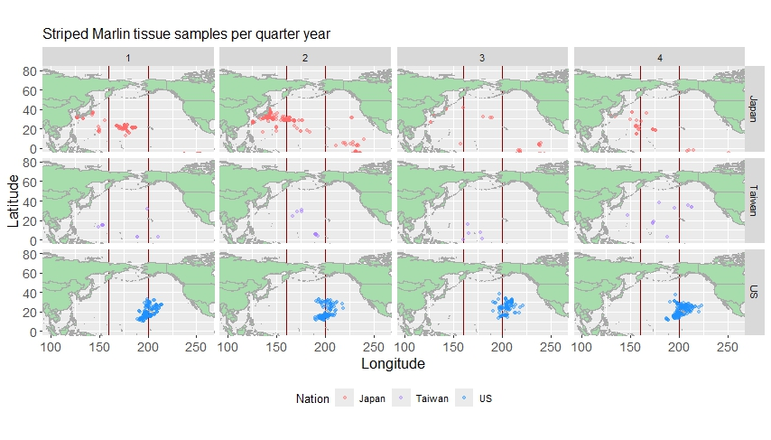
Figure 2 Distribution of Striped Marlin muscle tissue samples collected by Japan, Taiwan and the United States by quarter year, based on IBBS data as of November 26, 2025. Samples are categorized by region – Western, Central, and Eastern North Pacific – divided by 160º east and west longitude.

Figure 3 Overview of the process from sample collection to data analysis

